**Carbon Neutral by 2050: The Rise of Corporate Environmentalism**

Corporate environmentalism has emerged as a pivotal factor shaping the future. The target of achieving carbon neutrality by 2050, firmly established in the [Paris Agreement](https://www.un.org/en/climatechange/paris-agreement), has become a But

lodestar for companies worldwide.



[Source](https://unfoundation.org/blog/post/paris-climate-agreement-101-no-jargon-just-facts/)

In this article, we explore the rise of corporate environmentalism, the strategies underpinning the journey to carbon neutrality, and the imperative for corporations to embrace this transition.

## **Corporate Environmentalism: A Paradigm Shift**

The rise of corporate environmentalism represents a fundamental shift in the ethos of businesses. No longer can corporations afford to view environmental stewardship as a peripheral concern. Instead, it is becoming an integral aspect of their strategy, operations, and corporate identity. This evolution is spurred by a confluence of forces, including scientific consensus, regulatory pressures, stakeholder expectations, and market dynamics.

Scientific consensus has unequivocally linked [human activity, particularly greenhouse gas emissions, to global climate change](https://scienceexchange.caltech.edu/topics/sustainability/evidence-climate-change). As significant contributors to these emissions, corporations have a moral and practical imperative to act. The Intergovernmental Panel on Climate Change (IPCC) report underscores the urgency, stating that limiting [global warming to 1.5 degrees Celsius](https://www.ipcc.ch/sr15/) requires reaching net-zero carbon emissions by 2050.

Po

Regulatory pressures from governments worldwide are also driving corporate environmentalism. The Paris Agreement, ratified by 189 out of 197 Parties to the United Nations Framework Convention on Climate Change, sets the global agenda. Policymakers are translating this into national and local legislation, enforcing stricter environmental standards, and offering incentives for green initiatives.

Stakeholder expectations are evolving, too. Consumers increasingly prefer sustainable products and services, employees seek employers who share their environmental values, and communities demand businesses minimize their environmental impact. This shift is influencing corporate reputations, customer loyalty, and talent attraction.

Market dynamics are further propelling this transformation. As renewable energy sources become more affordable and efficient, transitioning to green energy is not only environmentally responsible but also economically viable. Similarly, sustainable practices often lead to cost savings in the long term, through improved resource efficiency and waste reduction.

## **The Roadmap to Carbon Neutrality**

Achieving carbon neutrality by 2050 requires comprehensive, strategic action on multiple fronts. The roadmap involves transitioning to renewable energy, adopting circular economy principles, investing in carbon capture and storage technologies, and leveraging carbon offset strategies.

Transitioning to renewable energy is at the core of this agenda. Corporations worldwide are committing to 100% renewable energy targets and investing in solar, wind, hydro, and other renewable energy sources. Energy efficiency measures, such as optimizing manufacturing processes and retrofitting buildings, are also critical.

The circular economy represents another key strategy. This approach seeks to minimize waste and make the most of resources by designing products for durability, reuse, and recycling, and by turning waste into a resource.

Carbon capture and storage (CCS) technologies offer another avenue for carbon reduction. These technologies capture carbon dioxide emissions from power plants and industrial processes and store them underground to prevent their release into the atmosphere. While still in the early stages of development, they hold significant potential.

Lastly, carbon offset strategies provide a means for companies to balance out their residual emissions. This involves investing in projects that reduce or remove greenhouse gases elsewhere, such as reforestation or renewable energy projects.

## **Path to Net-Zero: Practical Strategies for Corporations to Achieve Carbon Neutrality**

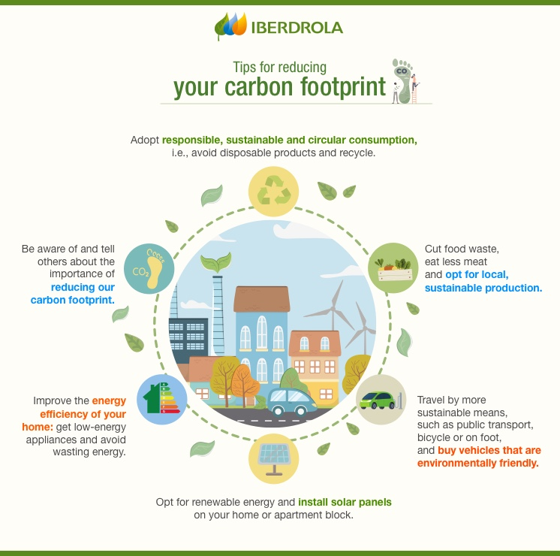

[Source](https://www.iberdrola.com/sustainability/what-is-carbon-neutrality)

Achieving carbon neutrality by 2050 is a challenging but essential goal for companies worldwide. Here are several practical strategies that can help companies on this journey:

### **Improve Energy Efficiency**

Companies should focus on optimizing their energy usage through energy-efficient machinery, lighting, heating, and cooling systems. Regular energy audits can help identify opportunities for efficiency improvements.

### **Switch to Renewable Energy Sources**

Transitioning to renewable energy sources, such as solar, wind, hydro, and bioenergy, is a key step towards carbon neutrality. Companies can install renewable energy systems, procure renewable energy, or purchase renewable energy certificates.

### **Incorporate Circular Economy Principles**

By designing products and packaging for durability, reuse, and recyclability, companies can reduce their demand for new resources and minimize waste, thus lowering their carbon emissions.

### **Invest in Carbon Capture and Storage (CCS)**

Although still emerging, [CCS technology can capture CO2 emissions](https://www.nationalgrid.com/stories/energy-explained/what-is-ccs-how-does-it-work) at their source and store them underground. This technology can be particularly useful for industries with high emissions that are difficult to eliminate.

### **Offset Carbon Emissions**

Companies can compensate for their unavoidable emissions by investing in certified carbon offset projects, such as reforestation, renewable energy, or community development projects.

### **Green Supply Chain Management**

Working with suppliers to implement sustainable practices can significantly reduce a company's indirect emissions. This could involve sourcing from local or certified sustainable suppliers or collaborating with suppliers to improve their environmental performance.

### **Promote Sustainable Consumption**

Companies can help reduce emissions by offering eco-friendly products and services, providing transparent product information, and encouraging sustainable consumption habits among their customers.

### **Engage Employees**

Employee engagement in sustainability initiatives can create a culture of sustainability, foster innovation, and improve overall environmental performance. Companies can provide sustainability training, set up employee green teams, or introduce incentive programs for green ideas or behaviors.

### **Transparent Reporting and Verification**

Regularly measuring, reporting, and verifying environmental performance is essential for tracking progress toward carbon neutrality, identifying areas for improvement, and demonstrating a commitment to stakeholders.

### **Advocate for Policy Change**

Companies can use their influence to advocate for climate-friendly policies and regulations, either individually or through industry associations. They can also engage in public-private partnerships to drive systemic change.

## **Perils of Inaction: The Multifaceted Risks for Businesses Ignoring the Path to Carbon Neutrality**

The risks of companies not adhering to the strategies of achieving carbon neutrality are significant and multifaceted, encompassing regulatory, financial, reputational, and operational aspects:

### **Regulatory Risks**

As the global community moves towards stricter environmental standards, companies not working towards carbon neutrality may face increasingly stringent regulations. Non-compliance can lead to hefty fines, sanctions, or even business restrictions.

### **Financial Risks**

Investors are progressively considering environmental performance when making investment decisions. Companies that fail to align with carbon neutrality may struggle to attract investors. Furthermore, the shift towards a low-carbon economy may render certain assets or business models obsolete, resulting in stranded assets.

### **Reputational Risks**

Consumers, employees, and the public increasingly expect companies to take responsibility for their environmental impact. Companies not working towards carbon neutrality may suffer reputational damage, potentially affecting customer loyalty, employee retention, and overall brand value.

### **Operational Risks**

Climate change itself presents operational risks. Extreme weather events, for example, can disrupt supply chains and damage infrastructure. Transitioning to a carbon-neutral operation can help companies mitigate these risks by making their operations more resilient.

### **Market Risks**

The market is steadily moving towards greener products and services. Companies that fail to innovate and adapt risk losing market share to competitors that are better able to meet this growing demand.

### **Legal Risks**

There's an increasing trend of litigation related to climate change. Companies might face lawsuits from shareholders, communities, or governments if they fail to address their climate impact or disclose climate-related risks.

### **Access to Capital**

Banks and financial institutions are increasingly integrating climate risk into their lending decisions. Companies not aligning with the transition to a low-carbon economy may find it more challenging to secure financing.

While the transition to carbon neutrality presents challenges, the risks of inaction are significant and far-reaching. By taking proactive steps towards carbon neutrality, companies can mitigate these risks and seize the opportunities of the transition to a low-carbon economy.

## **The Imperative of Corporate Environmentalism**

The goal of achieving carbon neutrality by 2050 is an ambitious yet vital objective, and corporate environmentalism is a key component in reaching this target. Companies that embrace this transition stand to gain both environmental and business benefits. They can improve their risk profile, foster innovation, enhance their reputation, attract talent, and meet the evolving demands of customers, investors, and regulators.

However, corporate environmentalism requires more than mere pledges; it necessitates action. It calls for rigorous greenhouse gas accounting, transparent reporting, and the integration of sustainability into all aspects of a company's operations. It also calls for active engagement with various stakeholders to collectively advance this agenda, including employees, customers, suppliers, regulators, and local communities.

Importantly, corporate environmentalism should not be seen as a burden but as an opportunity. The transition to a low-carbon economy is expected to fuel technological innovation, generate jobs, and create new business opportunities. Moreover, companies that take the lead in this transition will be well-positioned to capture these opportunities and gain a competitive edge.

In a rapidly changing world, flexibility and adaptability are key to business survival and success. Climate change presents a massive challenge but also a chance for businesses to evolve, innovate, and thrive. The journey towards carbon neutrality by 2050 will undoubtedly be challenging, but with commitment, collaboration, and creativity, it is a goal within reach.

Corporate environmentalism is not just about preserving the environment for future generations. It is about creating a resilient and sustainable business model that can withstand the test of time. It is about recognizing that the health of our economy, society, and planet are inextricably linked. And it is about stepping up to take responsibility, lead the way, and positively impact the world.

As we look toward the future, one thing is clear: corporate environmentalism is not just a trend; it's a fundamental shift in how businesses operate. The race to carbon neutrality by 2050 is on, and it's a race we cannot afford to lose. Let's seize this opportunity to create a sustainable, prosperous, and resilient future for all.